Part 1

Answer 1 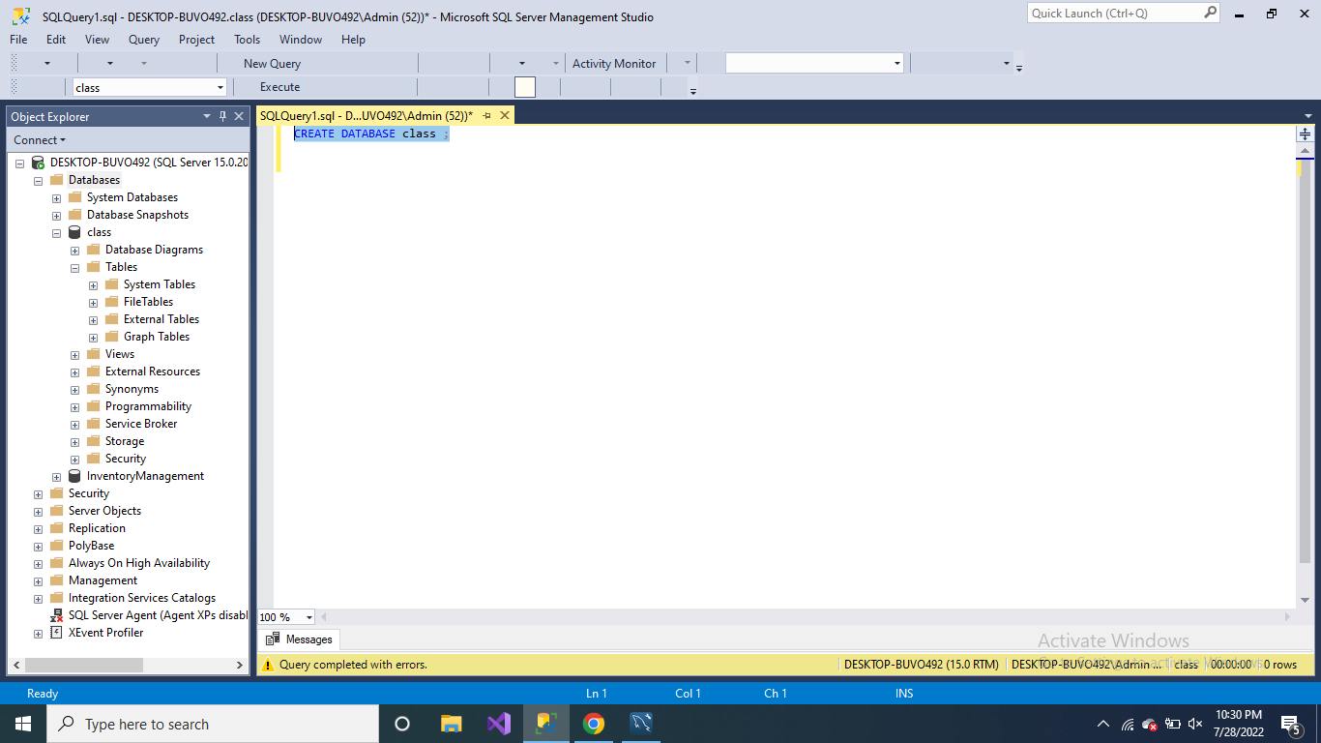

Answer 2

USE class;

CREATE TABLE Students(

StudentId int NOT NULL,

FirstName nvarchar(50),

LastName nvarchar(5),

PRIMARY KEY (StudentId)

);

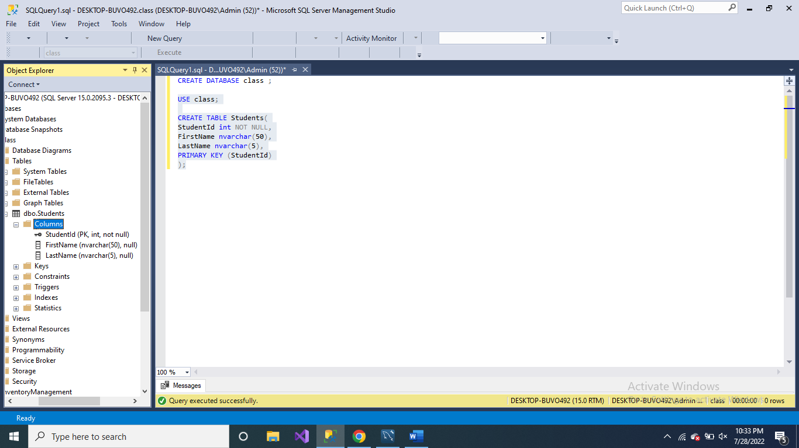

Answer 3

alter table Students

add MiddleName varchar(20);

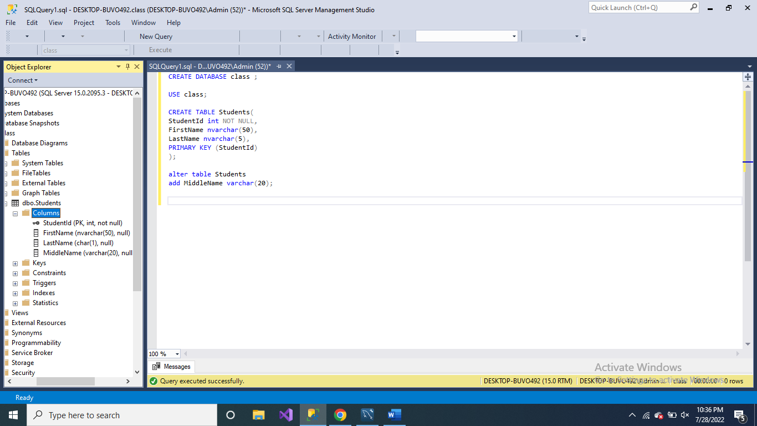

Answer 4

alter table Students

drop COLUMN MiddleName;

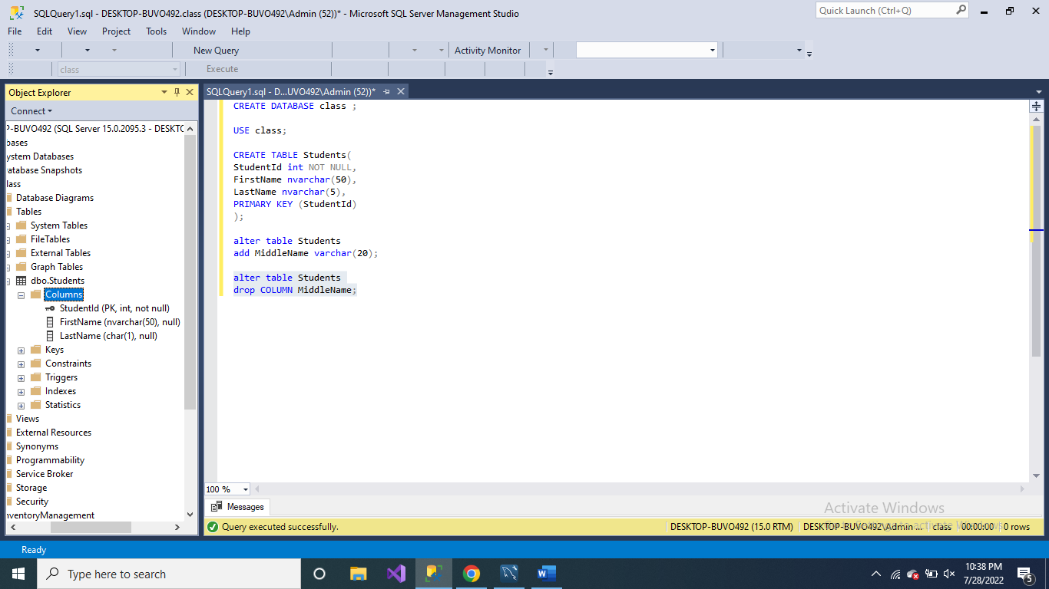

Answer 5

alter table Students

alter COLUMN LastName char;

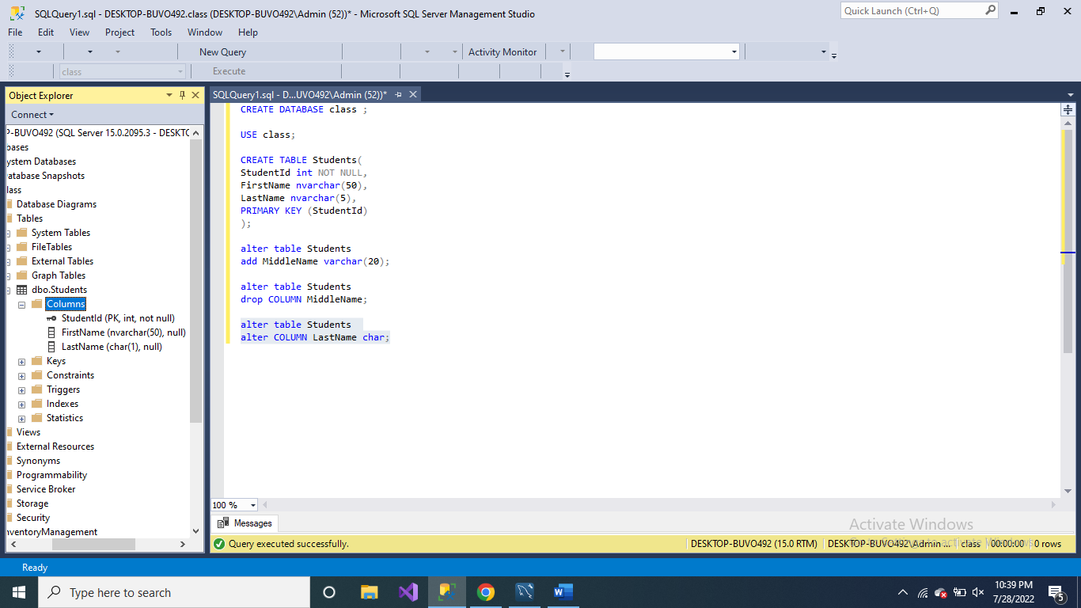

Part 2

Answer 1

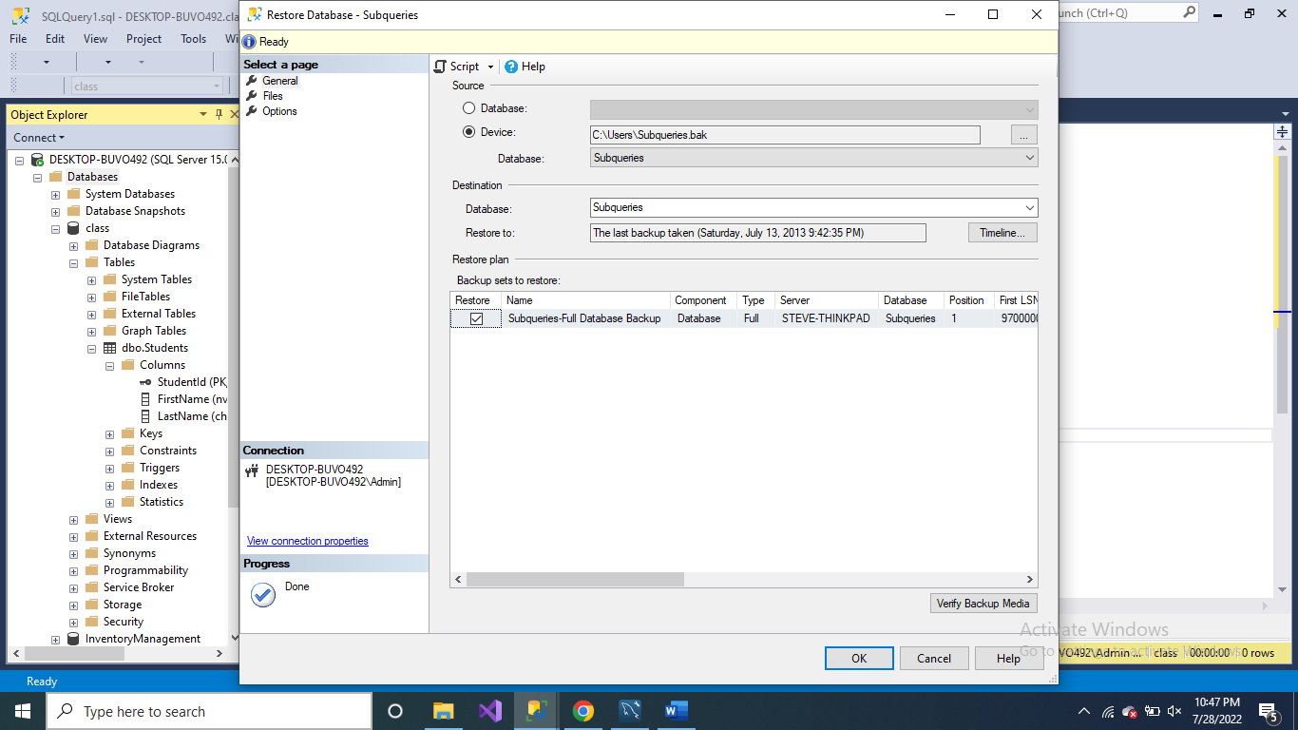

Answer 2

USE Subqueries

INSERT INTO SalesPerson(EmpID, First_Name, Last_Name)

VALUES (900, 'Hossein', 'Hesami'),

(901, 'Amir', 'Khan'),

(902, 'Rishi', 'Kapoor'),

(903, 'Ranbir', 'Kapoor'),

(904, 'Hritik', 'Roshan');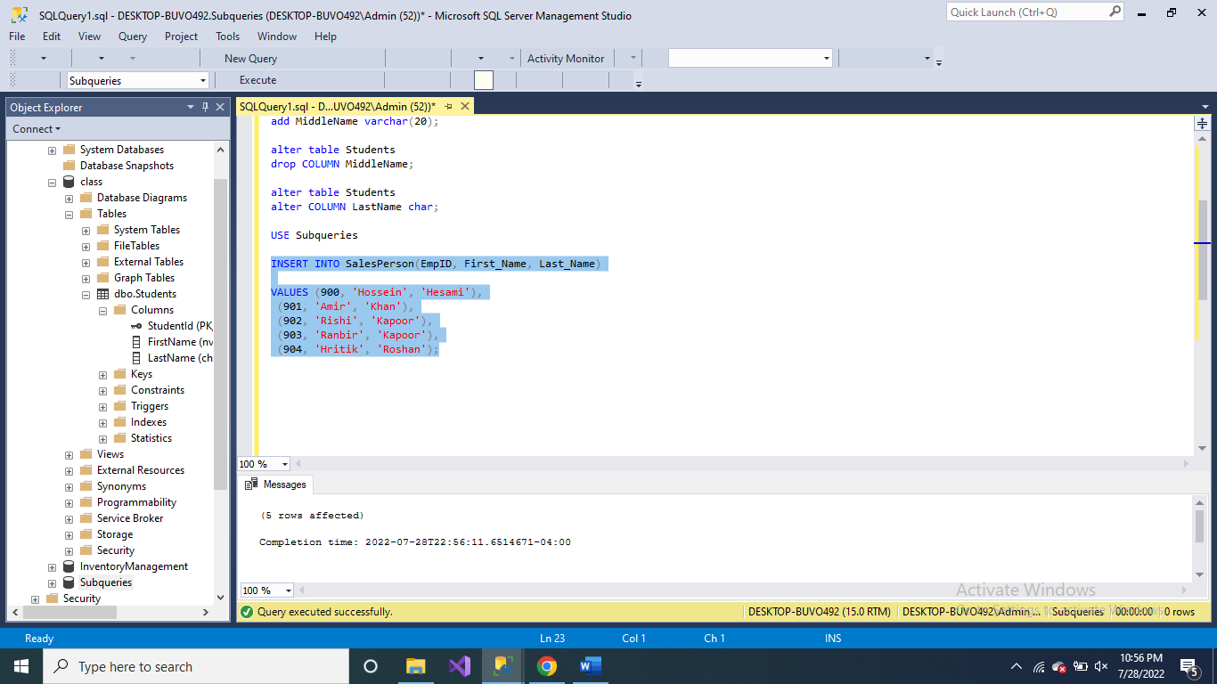

Answer 3

SELECT COUNT(*) FROM SalesPerson;

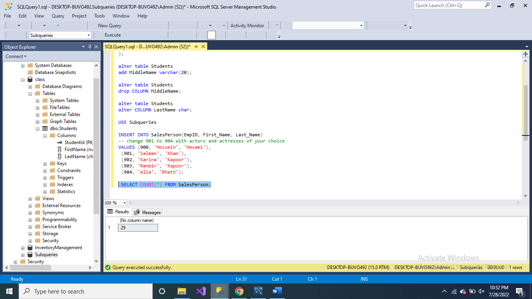

Answer 4

DELETE FROM SalesPerson WHERE EmpID = 900;

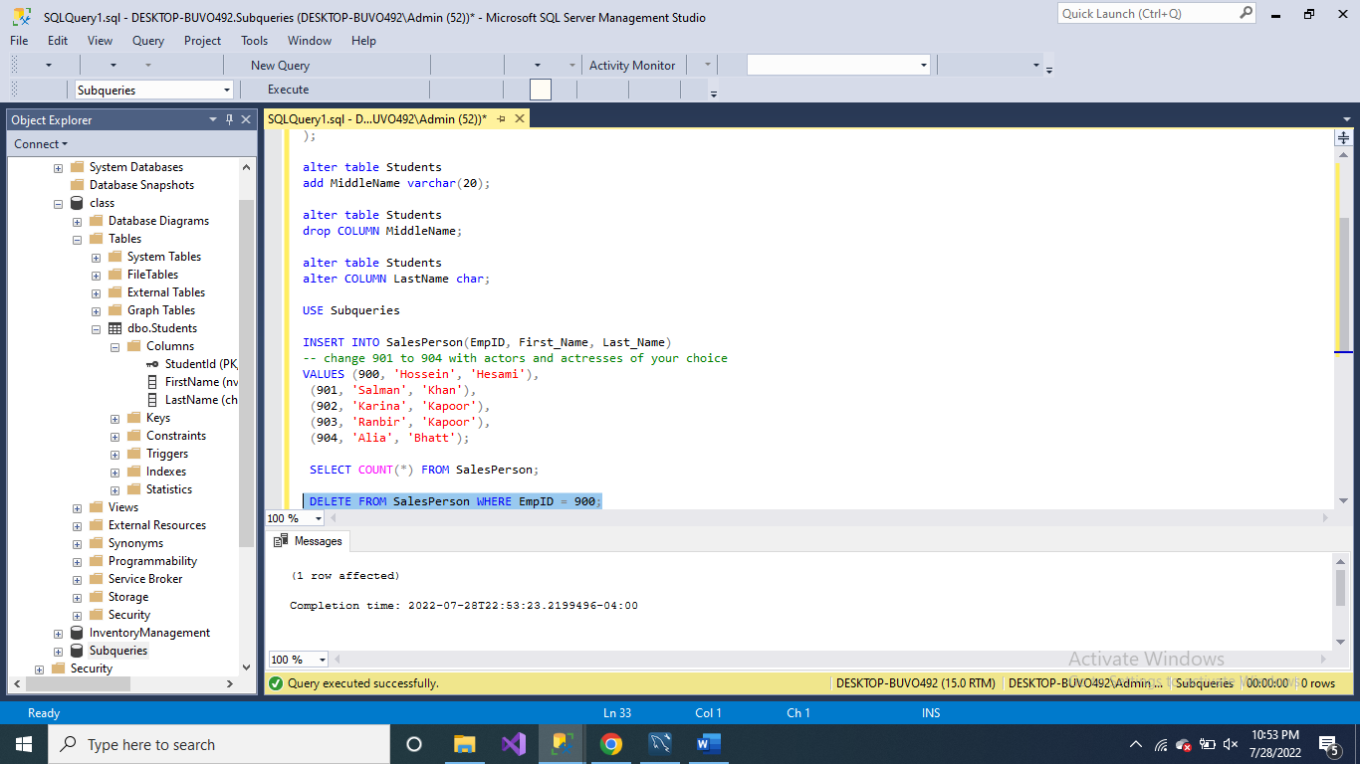

Answer 5

INSERT INTO SalesPerson(EmpID, First_Name, Last_Name)

-- add your student id in place of 145

VALUES (145, 'Sanskar', 'Parihar'); 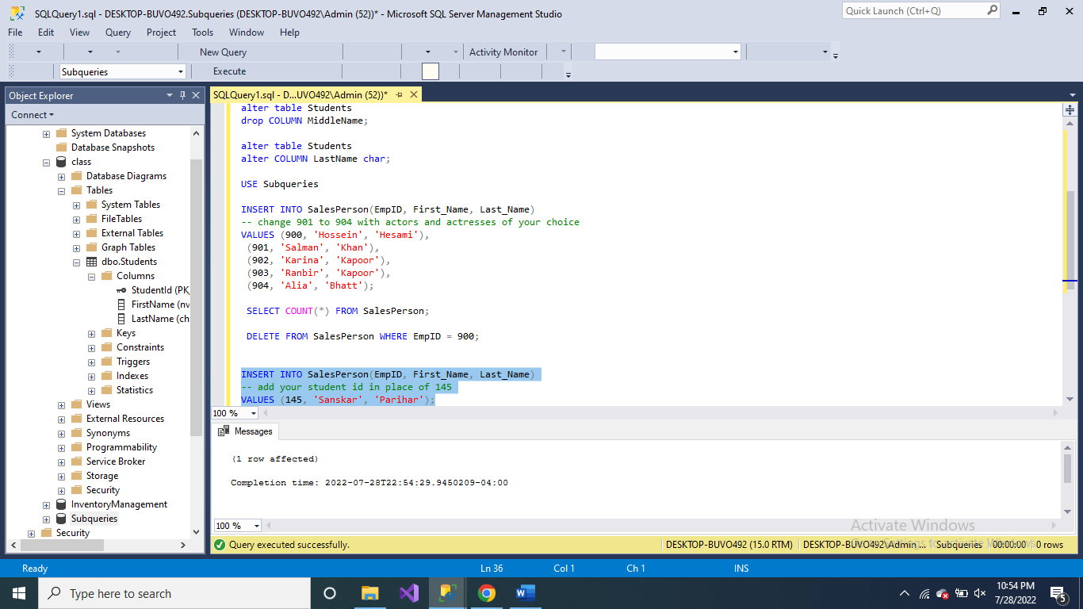

Answer 6

UPDATE SalesPerson

SET First_Name = 'John'

WHERE EmpID = 20; 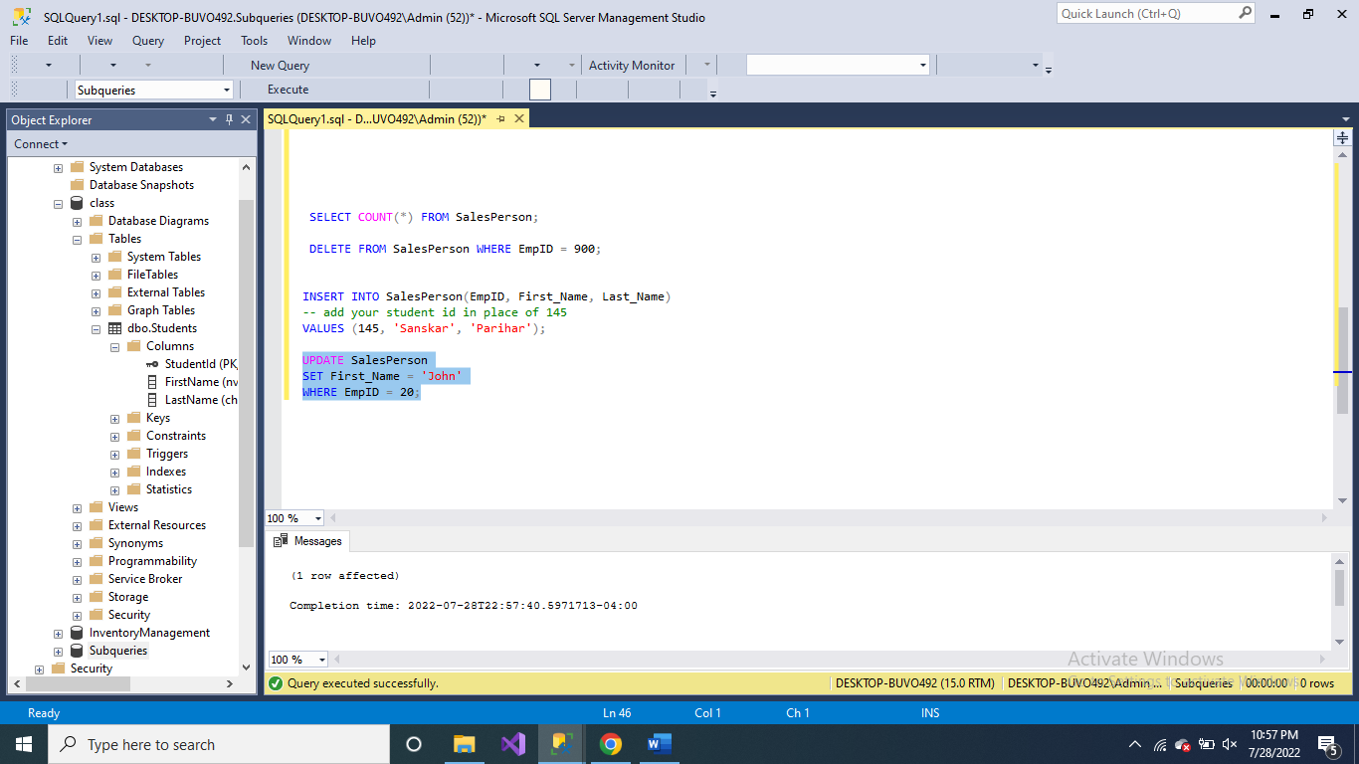

Answer 7

UPDATE SalesPerson

SET Last_Name = 'Doe'

WHERE EmpID = 20; 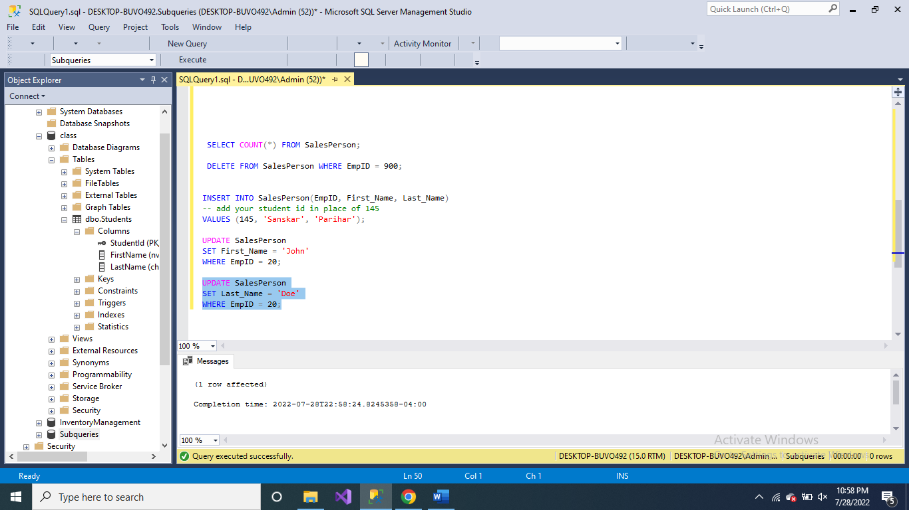

Answer 8

UPDATE SalesPerson

SET First_Name = 'Sara', Last_Name = 'Cyrus'

WHERE EmpID = 20; 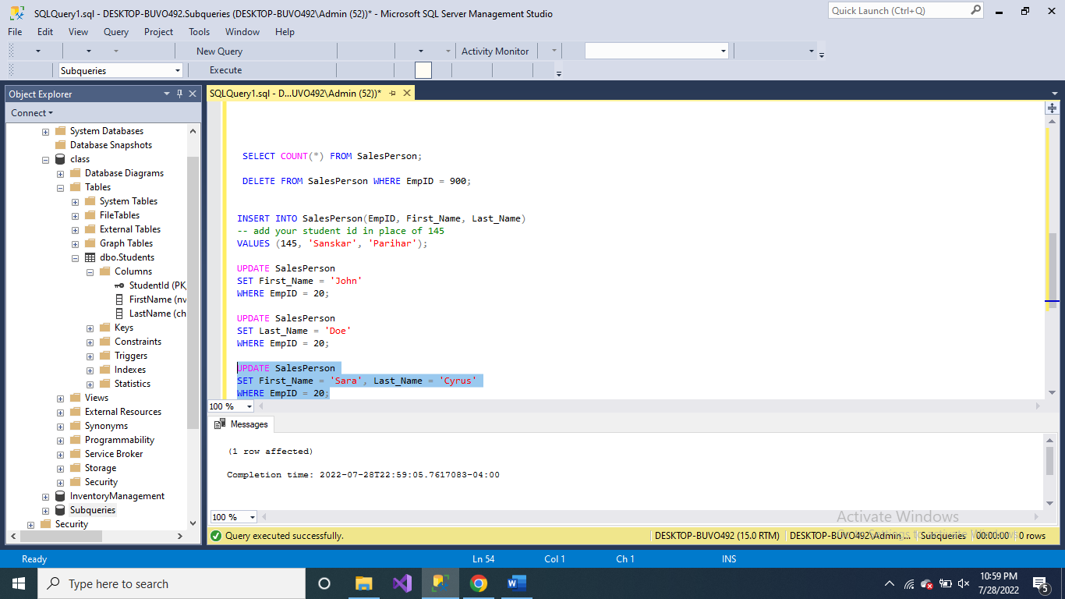

Answer 9  
INSERT INTO SalesPerson(EmpID, First_Name, Last_Name)

VALUES (30, 'Tom', 'Faubert');

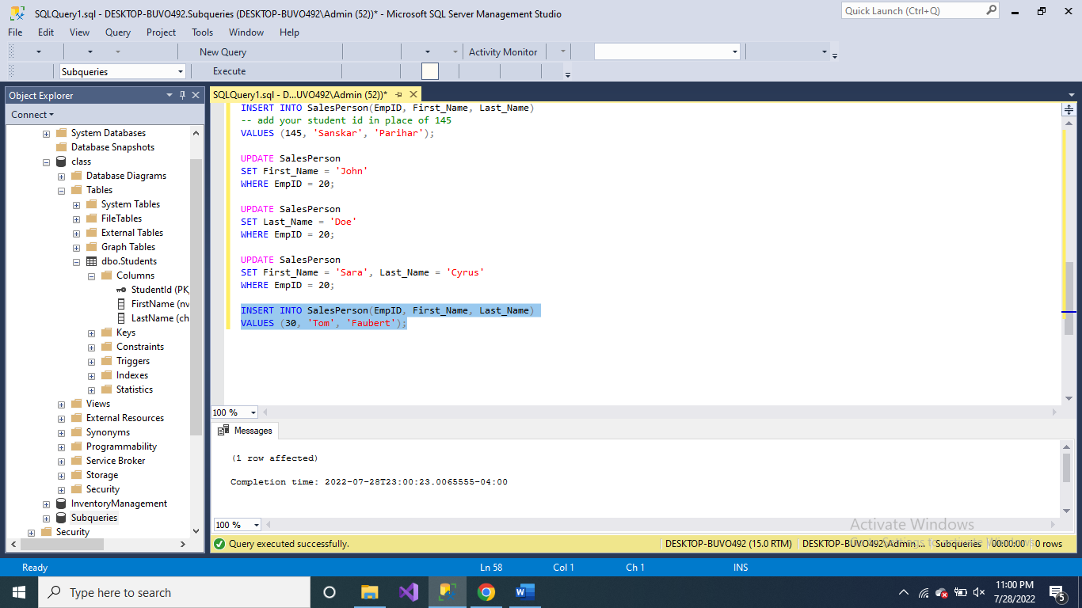

Answer 10

INSERT INTO SalesPerson(EmpID, First_Name, Last_Name)

VALUES (10, 'Hossein', 'Hesami'); 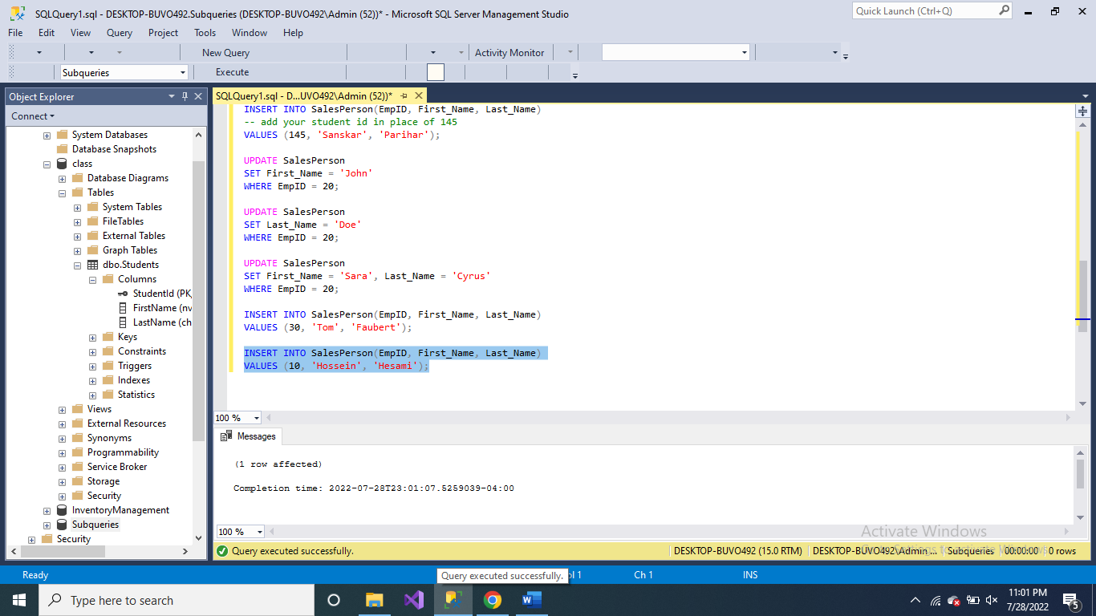

Part 3

UPDATE Production.Product

SET ListPrice = ListPrice * 1.05

FROM Production.Product p

INNER JOIN Production.ProductSubcategory ps

ON p.ProductSubcategoryID = ps.ProductSubcategoryID

WHERE ps.Name = 'Socks';